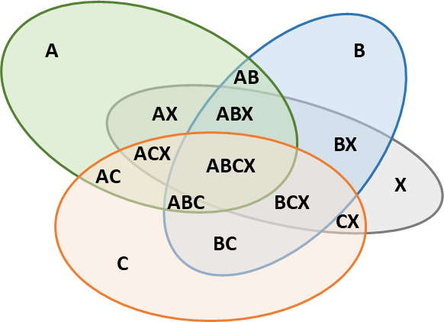Accidentals Type 1 (two events outside that go in) for LDX

|  |  |
| --- | --- |
| Accidental ABX | |
| pA | pBX |
| pB | pAX |
| pX | pAB |
| pAB | pAX |
| pAB | pBX |
| pAX | pBX |

|  |  |
| --- | --- |
| Accidental ACX | |
| pA | pCX |
| pC | pAX |
| pX | pAC |
| pAC | pAX |
| pAC | pCX |
| pAX | pCX |

|  |  |
| --- | --- |
| Accidental BCX | |
| pC | pBX |
| pB | pCX |
| pX | pCB |
| pCB | pCX |
| pCB | pBX |
| pCX | pBX |

|  |  |
| --- | --- |
| Accidental ABCX | |
| pABC | pX |
| pABC | pCX |
| pABC | pBX |
| pABC | pAX |
| pAB | pCX |
| pAC | pBX |
| pAX | pBC |

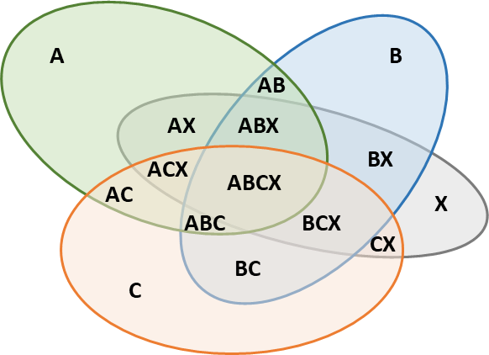Accidentals Type 2 (one event outside and one inside) for LDX

|  |  |
| --- | --- |
| Accidental ABX | |
| pA | pABX |
| pB | pABX |
| pX | pABX |
| pAB | pABX |
| pAX | pABX |
| pBX | pABX |

|  |  |
| --- | --- |
| Accidental ACX | |
| pA | pACX |
| pC | pACX |
| pX | pACX |
| pAC | pACX |
| pAX | pACX |
| pCX | pACX |

|  |  |
| --- | --- |
| Accidental BCX | |
| pB | pBCX |
| pC | pBCX |
| pX | pBCX |
| pBC | pBCX |
| pBX | pBCX |
| pCX | pBCX |

|  |  |
| --- | --- |
| Accidental ABCX | |
| pA | pABCX |
| pB | pABCX |
| pC | pABCX |
| pX | pABCX |
| pAB | pABCX |
| pAC | pABCX |
| pAX | pABCX |
| pBC | pABCX |
| pBX | pABCX |
| pCX | pABCX |
| pABC | pABCX |